[E124] Heat exchanger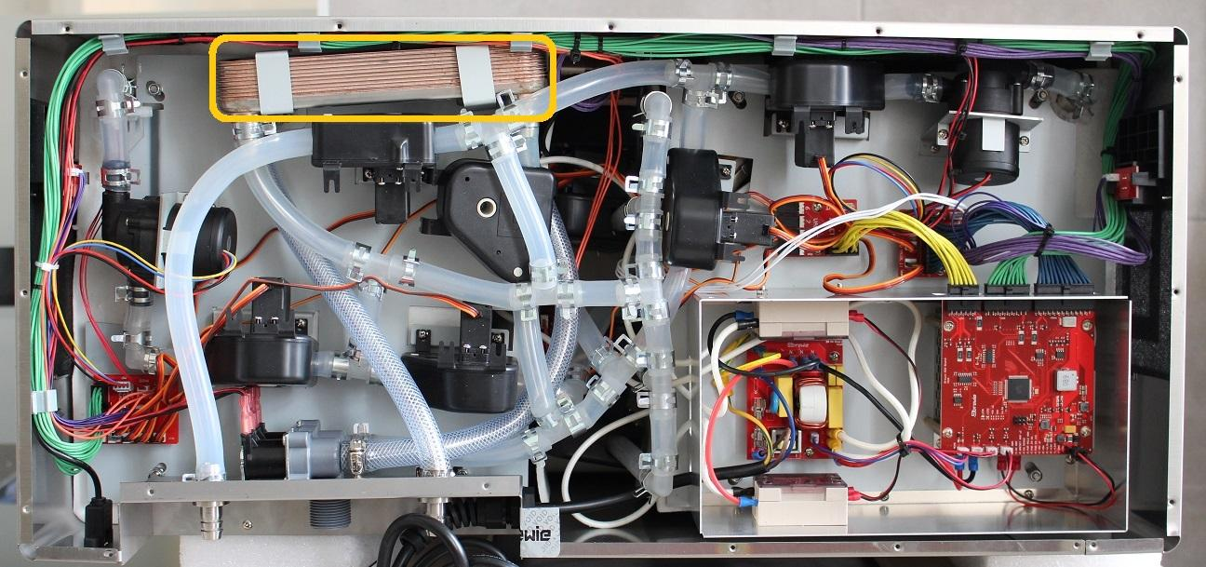

First pull off the hose clamp from the wort outlet fitting and pull off the silicone tube from the outlet. Unscrew the fastening screws of the outlet valve and disconnect it from the PCB. Pull off the other marked hose clamp on the pipeline and disconnect the pipes. Then these tubes can be bent to the mash side.

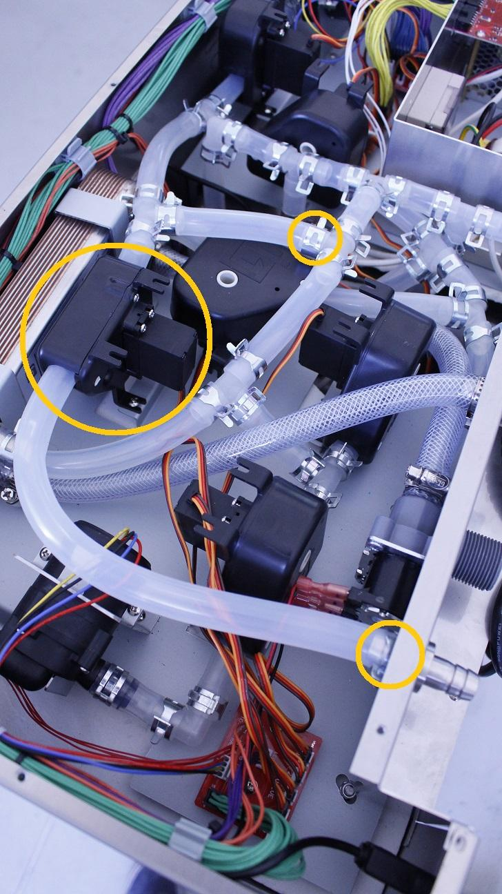

Secondly, remove the screws of the fastening clamps of the heat exchanger. Remove the clamps.

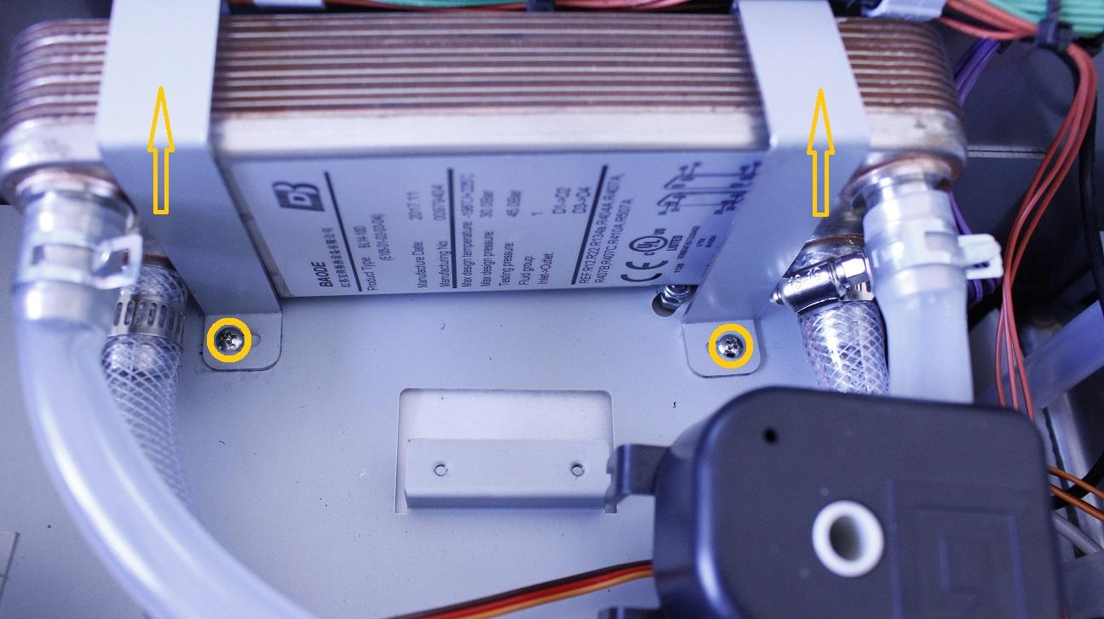

Third, pull off the marked hose clamp to disconnect the silicone pipes, remove the clamp. Unplug the cooling valve from the PCB and remove the valve.

Pull off/unscrew the clamps from the fittings of the heat exchanger and disconnect the pipes.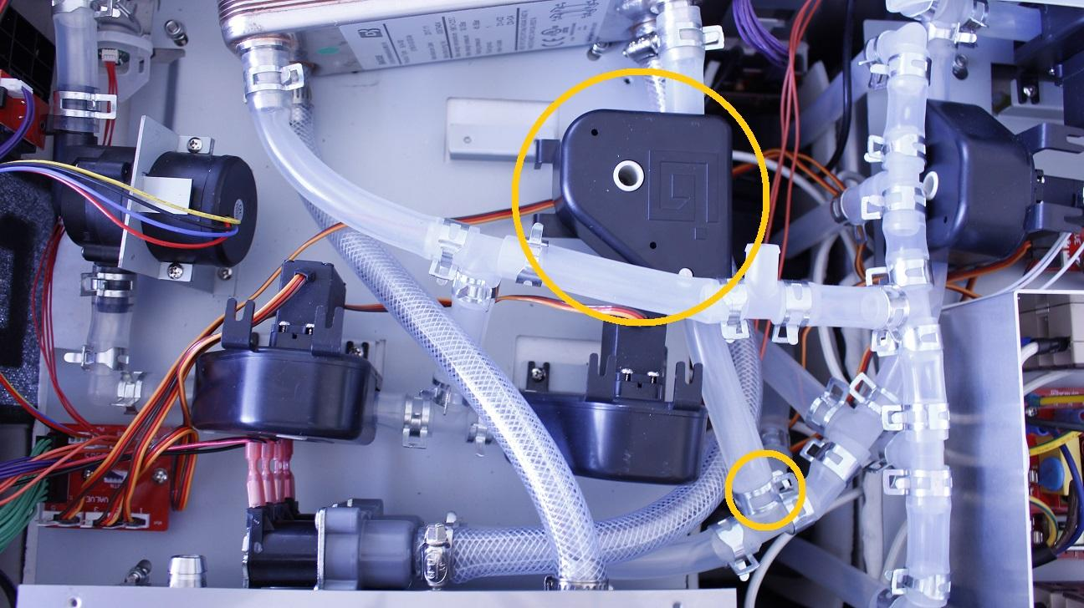

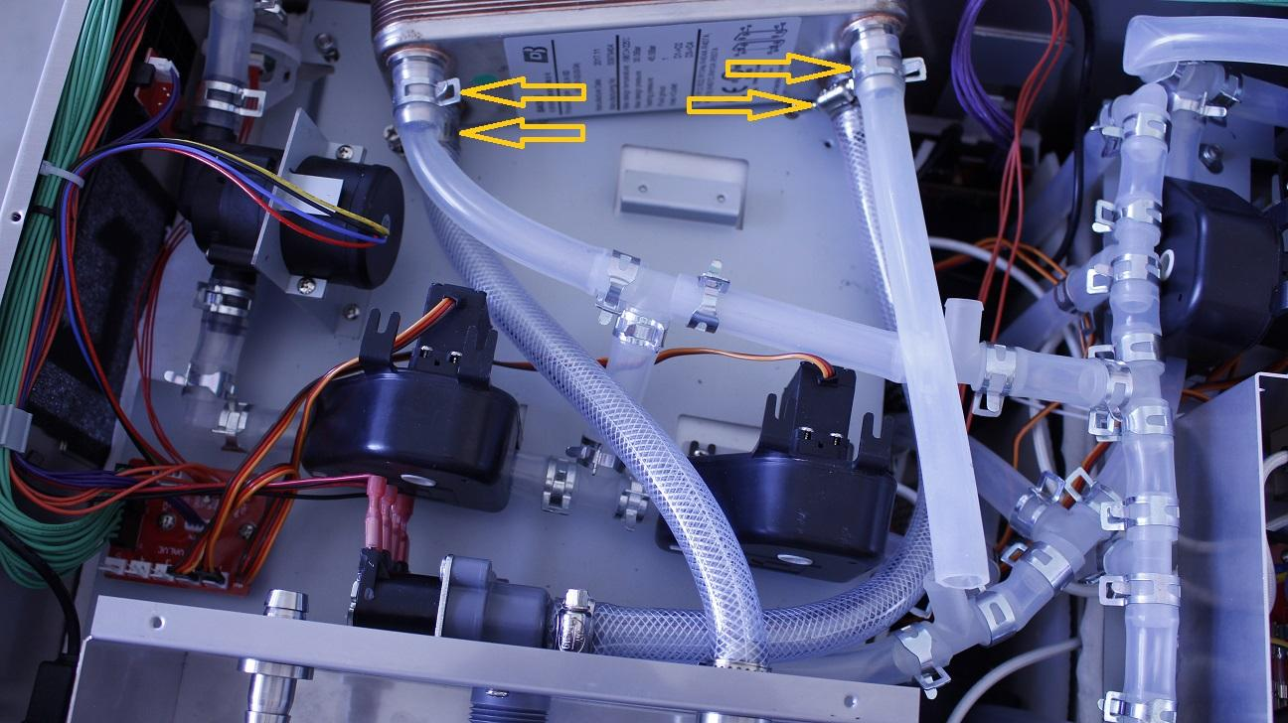

The heat exchanger can be removed now.

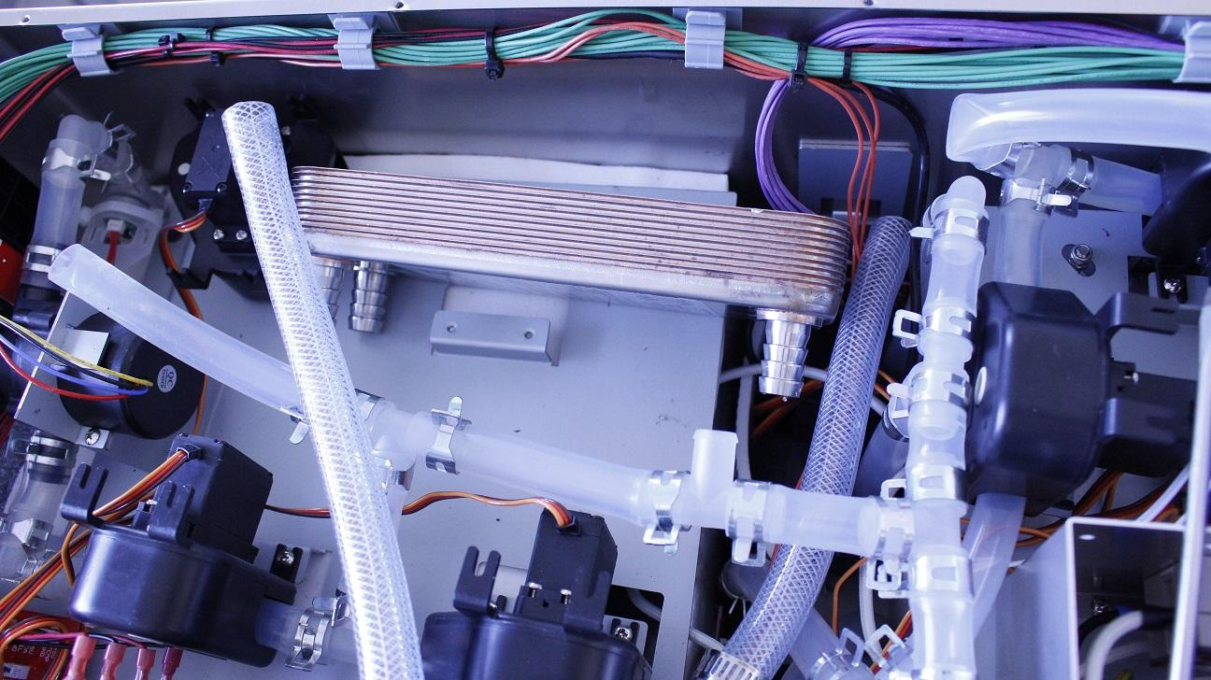

Reassemble consists of the same steps in reverse.

Make sure that the wort outlet hose clamp is in the proper angle. Otherwise you cannot reassemble the bottom sheetmetal.

